S.A.E COMPETITION MICRO AIRCRAFT DESIGN.
Student Name
Institution
Course Name/Number
Due Date
Instructor Name

LITERATURE REVIEW
Micro Aircraft form an essential part of the aviation industry like the iStar outlined the physical dimensions and weight expectations associated with flying a device with high forward speeds at particular attitudes (Lipera et al., 2001). This 4lb and 9-inch diameter of duct air vehicle also highlighted the potential of increasing the propulsion efficiency and producing a particular lift for horizontal flight, identical to traditional planar wings. Finally, it outlined the operation criteria for aero craft control with piezo-electric gyroscopes and rate-based control systems that allow processing of flight commends and better stabilization in air. Finally, it presented this iStar Micro Air vehicle predicted the anticipated development time and flight-test results through the pitch angles and speeds.
Micro aircraft design relates to small ducted fans aero crafts because of their internal architecture, i.e., flight control and electronics system, upper-centre body made of the fixed-pitch propeller, engine control, payload. Past flight tests, controls, and micro-ducted aircraft models highlighted the need to offer autonomous capabilities to suit urban environment missions (Johnson and Turbe, 2006). It proposed the inclusion of neural networks adaptation using dynamic inversion neural networks that deliver adaptive controller capabilities for better flight testing and performance. This micro aerial vehicle's design lies in creating a hierarchical controller for better landing and vertical takeoff stability plus attitude control (Pflimlin et al., (2006, May). The methodology in this aircraft design offers the possibility of estimating unknown aerodynamic forces and stabilizing this air vehicle's position, directly contributing to its successful operation.
Aerodynamic prediction is vital for winning the S.A.E competition as obtained flight test information helps understand the vertical takeoff speeds and landing. Aerodynamic analysis for such air vehicles takes the approach of accounts for; operational concepts, mission requirement, payload specifications, design characteristics (Guerrero et al., 2003). Techniques in the design serve the end goal of proving accuracy and scalability using multi-disciplinary design optimization techniques, wind tunnel test information, semi-empirical aerodynamic methods and parametric geometrical models. Finally, it included the analytical design parameters such as; sweep angle, total drag co-efficient, cross-section lift co-efficient, taper ratio, density of air, attack angle, volume of body, dynamic pressure, velocity, thrust, Planform area, Reynolds number, Lifting Surface factor, Munk's span factor, Moment, maximum thickness, Thickness, correction factor, Gap distance, Span, Diameter and Drag.

BENCHMARK
In the S.A.E competitions, it is vital to meet various technical guidelines, safety and standard practices connected with the scope of Micro Aircrafts. Requirements from the 2-D drawings available on the S.A.E website indicate that the general design should conform with measurements from tape measures and carpenter squares with other tools, e.g. wingspan, overall length, and aircraft height. Additionally, it specifies that the mechanical steering mechanism should positively meet the attached linkages standards and landing gear specifications. Next, it specifies the requirements for the safety nuts secured in their aircraft's body for efficient micro-aircrafts. S.A.E also gives another rule for the discrete/removable red alarming plugs should be external i.e., either behind or in front of the propeller concerning the rotational plane. It continues to mandate that the male connection leads exposed in the aircraft should concur with the battery's overall length. In terms of battery, S.A.E requires that its compartment free from mechanical hardware in case of an accidental crash while maintaining the condition for its visibility from a measurable distance. Finally, it requires marking and design requirements to win leading and trailing edges with the horizontal suspension of micro-level aircraft.

DESIGN REQUIREMENTS
The criteria for developing this Micro-level Aircraft includes the assembly of four core elements; Landing Ring, Duct, Lower Center Body (L.C.B) and Upper Center Body (U.C.B). By convention, the composite material for building this aircraft is using Kevlar primarily because of its light-weight and strong structure. Additionally, the material offers a flexible nature different from other composite elements. Other Micro-Level Aircraft components use other materials like steel for the landing rings and Aluminium for the engine bulkhead despite these immense benefits.
U.C.B is the cylindrical structure made of the payload, propeller, engine control and the engine. The pass fuel and duct wiring get their support from hollow struts (three sets) integrated with the upper centre body. OS-32-SX Single Cylinder engine forms the commercial-off-the-shelf propulsion system also in the U.C.B. The engine that weighs 0.5lb has a 1.2hp rating and works with fuel made of a mixture of oil, nitro-methane and alcohol. The system lacks a gearbox to offer less weight contribution needed for the takeoff. It contains a fixed-pitch propeller that attaches to the engine's shaft-driven using the off-board electrical starter. The design incorporates a starting mechanism that allows this engine to insert the cylindrical shaft into its structure that contains a gear linked with the U.C.B. The latter contains less than eight screws used for mounting to allow the easy disintegration of parts in the aircraft
L.C.B contains stators that support this cylindrical structure that houses the sensor board. As the leading electronic component of the aircraft contains amplifiers, voltage regulators, accelerometers and piezo-electric gyroscopes. Additionally, it contains a Printed Circuit board that routes the sensor signals with the processor board and stators

COURSEWORK
Optimization and analysis of Micro-aircraft lie in computational software with state-of-the-art integration, evaluation, design techniques. CONDUIT i..e., Control Design Unified Interface allows the definition of system models, design specification and multi-objective functional optimizations for particular parameters. It does this through its interface connection with MATLAB Simulink that allows the simulation of the flight control and vehicle dynamics system using a linear state-space model. Therefore the analysis takes an intuitive approach using the control and stability derivatives from non-linear simulation models taken from wind tunnel information. The Low-speed wind tunnel data allows the simulation of this air vehicle at applied double-sided perturbations and hover conditions using the calculated derivatives. Agreement between the non-linear & linear models through comparisons offer the possibility to study the hover flight conditions.
Additionally, it allows the extraction of actuator dynamics from control vanes using system identification tools that model non-linear second-order systems with natural frequencies and damping ratios. Using the rate and position limits of this vane saturation allows the modelling of the engine throttle actuate and its respective second lag for better flight approximation. Handling quality design specifications, performance, and stability analysis for the Flight control system is also in this design's scope through the attitude information, angular rates, and P.I.D tuning parameters. The analysis results serve the purpose of delivering a smaller air vehicle with faster aerodynamics based on crossover frequencies evidenced from the yaw and pitch channels. It originates from step response plots for the pitch attitudes that can indicate the aircraft's natural tendency to return to its hovering position. Optimization of the design, e.g., through reducing the gyroscopic coupling, lies in the better damping ratios and minimized crossover frequencies obtained from the analysis
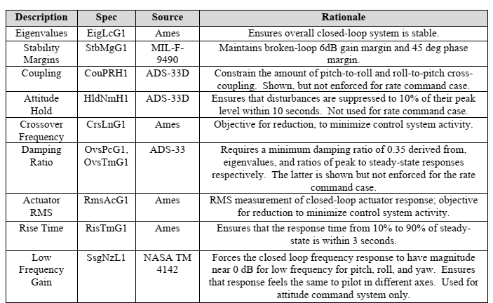
Table summarizing the Aerodynamic CONDUIT parameters.

WORK-PLAN
The summary of the work schedule is as follows
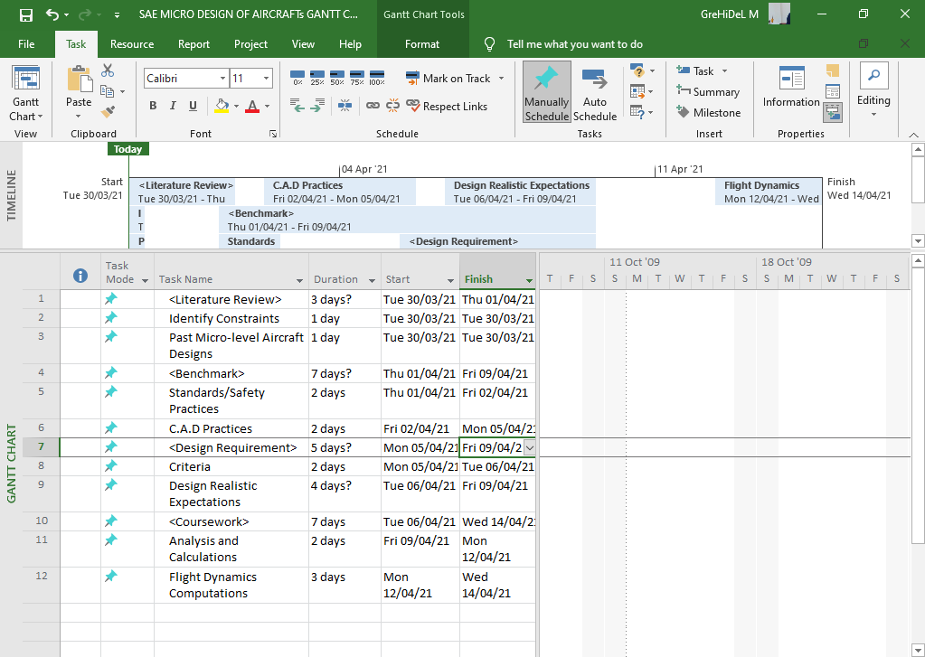
Figure: Gantt Chart related to this project.

MINUTES OF MEETING
The section indicates the Minutes from the first meeting with team members and Department's leaders as the guests. This meeting's agenda was to inform and update all the S.A.E competition members that seek to promote the application of engineering ideas in developing a Micro-level Aircraft.
DHARMA TEAM- UNIVERSITY OF MANE
MINUTES OF MEETINGS
Members in Attendance |  | Ava, M.M., Jade, K.E, Samelo, P.N., Santiago, M.A, Seba, N.J. and Scarlette, N.H
Members not in Attendance |  | None
Guests (Department Leaders) |  | Dr Amber, D.B, Dr Daphne, N. E, Dr Atticus, J.H.
Call to Order | The first meeting discussed the scope, risk factors, boundaries, milestones, implementation strategy, resources framework, deliverables, timelines, project dependencies related to design & actualization of Micro-level Aircraft as part of S.A.E. competition.
GENERAL OVERVIEW
- Members formulated a goal plan in a chart that outlined the short and long-term vision of this Micro-level Aircraft after explaining their fundamental goals & objectives.
- Members explained their inspiration, interest and future goals to the departmental leaders.
- Dr Amber, the C.O.D, commended Dharma team members for their grit and promising research on the topic, where he noted the practical importance.
- Dr Amber cleared the air concerning the budget allocations.
- Dr Daphne agreed with the team supervisors to be the lead consultant, with students agreeing to consult with her every Wednesday.
- Dr Atticus proposed integrating technologies like Neural Network with Heuristic controller in the design and implementation of Micro-level aircraft concerning this S.A.E competition.

REFERENCES
Guerrero, I., Londenberg, W. K., Gelhausen, P., & Myklebust, A. (2003, September). A powered lift aerodynamic analysis for the design of ducted fan UAVs. In 2nd AIAA" Unmanned Unlimited" Conf. and Workshop & Exhibit (p. 6567).
Johnson, E. N., & Turbe, M. A. (2006). Modelling, control, and flight testing of a small-ducted fan aircraft. Journal of guidance, control, and dynamics, 29(4), 769-779.
Lipera, L., Colbourne, J. D., Tischler, M. B., Mansur, M. H., Rotkowitz, M. C., & Patangui, P. (2001, May). Micro craft iSTAR micro air vehicle: Control system design and testing. In Annual Forum Proceedings-American Helicopter Society (Vol. 57, No. 2, pp. 1998-2008). AMERICAN HELICOPTER SOCIETY, I.N.C.
Pflimlin, J. M., Hamel, T., Soueres, P., & Mahony, R. (2006, May). A hierarchical control strategy for the autonomous navigation of a ducted fan flying robot. In Proceedings 2006 IEEE International Conference on Robotics and Automation, 2006. ICRA 2006. (pp. 2491-2496). IEEE.

